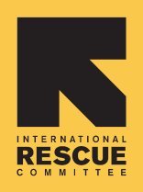
ECHO logo
International Rescue Committee –Ethiopia
COMMUNITY WELLBEING INITIATIVE PROGRAM

EVALUATION REPORT

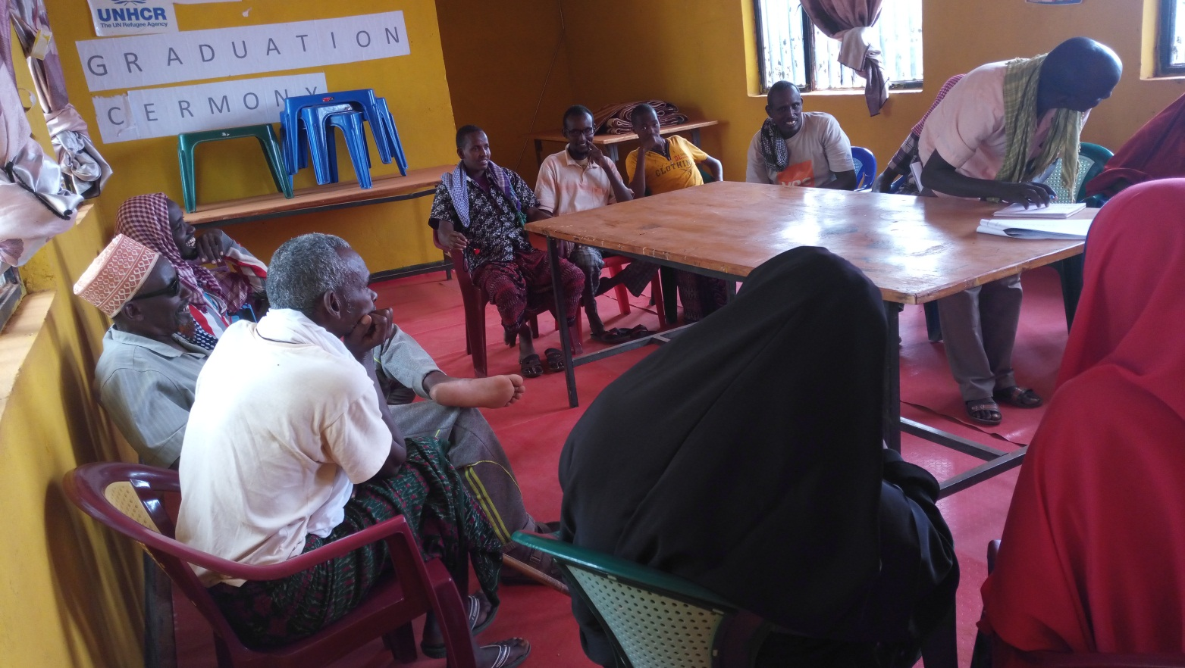

SUBMITTED TO: INTERNATIONAL RESCUE COMMITTEE

CONSULTANT: AHA PSYCHOLOGICAL SERVICES PLC

JUNE 2017
ADDIS ABABA
ETHIOPIA

EXECUTIVE SUMMARY
This terminal evaluation report refers to the IRC CWI-GBV prevention and response program which has been implemented from 2012 to 2016 in Tigray, Beneshangul Gumuz and Somali National Regional States with the financial support of European Commission Humanitarian Aid and Civil Protection Department (ECHO). The aim of the program was to ensure GBV survivors have access to quality health; protection and psychosocial support services and refugee men and women take action to improve the status of vulnerable women and girls. Specifically, CWI program was designed with the expected results of:
- GBV survivors and vulnerable women and girls have access to lifesaving services and other opportunities, including psychosocial support and safe space activities,
- Women and girls have increased business-related skills and knowledge and are able to take advantage of economic opportunities in Mai Ayni and Adiharush camps,
- Community knowledge and awareness of GBV is improved and contributes to mitigating risks and vulnerability of women and girls in the camps,
- Coordination of GBV data collection, monitoring and analysis across GBV multi-response services is improved.
The evaluation had focused on assessing CWI-GBV prevention and response program relevance, effectiveness, efficiency, impact and sustainability against the above expected program results. In order to do these, quantitative and qualitative data were collected from relevant sources through the application of various and respondent specific data collection instruments. The quantitative and qualitative data were mainly collected from six camps in Tigray, Somali and BSG regional states to generate pertinent data. Overall, quantitative data were collected from 2194 vulnerable women and girls, people with disabilities, men and adolescent girls and boys from May 25 to June 3, 2017. Furthermore, 42 FGDs and 33 KIIs were conducted with CWI-GBV prevention and response program beneficiaries, IPs, relevant IRC field staffs, INGOs and other stakeholders. About 16 case stories were also compiled from the program beneficiaries and direct observations were made to the wellness centers, market place, outreach centers and RCC offices as available in the visited camps. Relevant secondary sources were also reviewed.

Data obtained through household survey were coded and entered into an SPSS package, cleaned through cross-tabulation and statistical reports were generated from the software. Descriptive statistics was used to discuss quantitative data and tables, figures and boxes are used to present the findings. Content analysis and thematic sorting were used to organize analyze, interpret and synthesize qualitative data obtained through KII, FGD, observations, case stories and document review. The major findings obtained through such participatory evaluation approach are presented in the following paragraphs.
- Quantitative and qualitative data sources of this evaluation have judged the CWI-GBV program components and its implementation strategies as highly relevant to meet the immediate and strategic needs of GBV survivors and most vulnerable women and girls in the refugee camps. The psychosocial and asset building activities and material supports in the wellness centers, the awareness raising strategies and targets as well as the capacity building, networking and partnership that have brought functional and effective referral and case management systems were all relevant to prevent and respond to GBV. The program complemented and supported the humanitarian aid missions of the GoE and UNHCR.
- The CWI-GBV program has demonstrated its effectiveness in terms of knowledge creation and awareness raising among program beneficiaries and IPs on GBV causes, consequences, prevention and response mechanisms. This was partly associated with declining GBV cases reported to CWI-GBV prevention and response program and relevant service providing IPs. Interviews, FGDs, case reports and field observations have also asserted the involvement of men in domestic activities in support of their wives as a result of the knowledge and awareness raising activities. The program was also effective in providing lifesaving psychosocial, health and counselling services to GBV survivors and the most vulnerable women and girls. The WGWC has been giving paramount psychological, emotional and material support for GBV survivor and vulnerable women and girls. The program has also effectively enhanced the capacities of the refugee community, IPs and IRC staffs and stakeholders’ partnership for a concerted effort to prevent and respond to GBV. The piloted business and entrepreneurship skill training opportunities were also important sources of lessons for future programming.
- IRC was able to implement its planned activities through various mechanisms. The referral system established was one of the most important program implementation strategies that have contributed to the program efficiency because GBV survivors received health, legal aid and material supports from IPs and partners without IRC budget and staff.
- With regard to program impact, CWI has saved lives and safeguarded the medico-legal and psychosocial health of GBV survivors. It has also enhanced IPs’ capacity and created synergy among relevant actors working to prevent and respond to GBV. The awareness raising activities were effective in positively influencing the knowledge, attitude and thinking of the refugee community towards GBV. Refugee women, men, girls and boys received information and developed better understanding about GBV causes, consequences and response mechanisms thereby majority of them know where to report GBV incidences and where to access psychosocial, health and protection services. These developments will contribute to sustainably prevent GBV incidences in the refugee camps.
- Given the myriads of achievements, socio-cultural practices are still playing critical roles for the continuation of GBV incidences. The “choose one” culture in Somali was not well addressed. Evidences are available that indicate unreported and under reported GBV cases across camps due to cultural factors. CWI program had also gaps in involving and engaging all relevant GBV prevention and response actors including law enforcing bodies. Some program activities such as material provisions, business activities and the WGWC were under resourced. School-based intervention, staff retention and implementation of the house visit strategy to create awareness on other vulnerable community groups had certain gaps.
- Based on the evaluation findings (strengths, limitations, opportunities and challenges) the following recommendations are suggested for future program development.
- At design stage, GBV awareness raising strategies and activities should focus on camp specific root causes (mainly socio-cultural and economic) and GBV prevalence rate. Awareness raising methods should also consider the experiences, educational status, socio-cultural and religious backgrounds of the target audiences. It should also integrate business and alternative household income generating options for GBV survivors and adolescent girls. Program design and implementation should also give sufficient attention to PWD, young girls, religious, community leaders, men and boys, law enforcing bodies and the refugee community in the GBV prevention and response program management cycle. Important program activities such as income generating activities and facilities such as the wellness centers should also be planned along with sufficient financial, material and human resources. It is also recommended to have well equipped outreach centers across camps where men and boys can access GBV related information and report GBV incidences. Program design should also include program sustainability strategies from the beginning.
- During implementation, IRC should further strengthen its partners and make use of its partnerships to implement some GBV prevention and response program components such as school based interventions, business and entrepreneurship trainings (i.e. income generating activities for GBV survivors), material supplies, protection and legal aid related issues. IRC needs to continuously identify such program components that would be beyond its expertise and mandate and try to implement them through IPs as far as they contribute to its GBV prevention and response mission.
Staff capacity development and retention, especially in counselling services must continue and get the required attention throughout the program management cycle. Response officers who provide professional counselling services and the social workers that are engaged in awareness raising activities must be well trained. Counsellors need to have user-friendly counselling manuals and guidelines. GBV prevention and response program needs also to have professional case managers, who will handle, document, analyze and report GBV cases. When staffs leave, there should be quick mechanism to fill the gap and crash program must be designed to equip them with the necessary skills.

Evidences from Somali region indicated dowry as one of the root causes of forced and early marriage. However, there were evidences that Eritrean migrants are less stable and not desirous to engage in business activities. They rather see Ethiopia as their transit to secondary migration and resettlement opportunity. As a result, some program components such as business activity must be camp specific and result oriented.

